Supplemental Figures

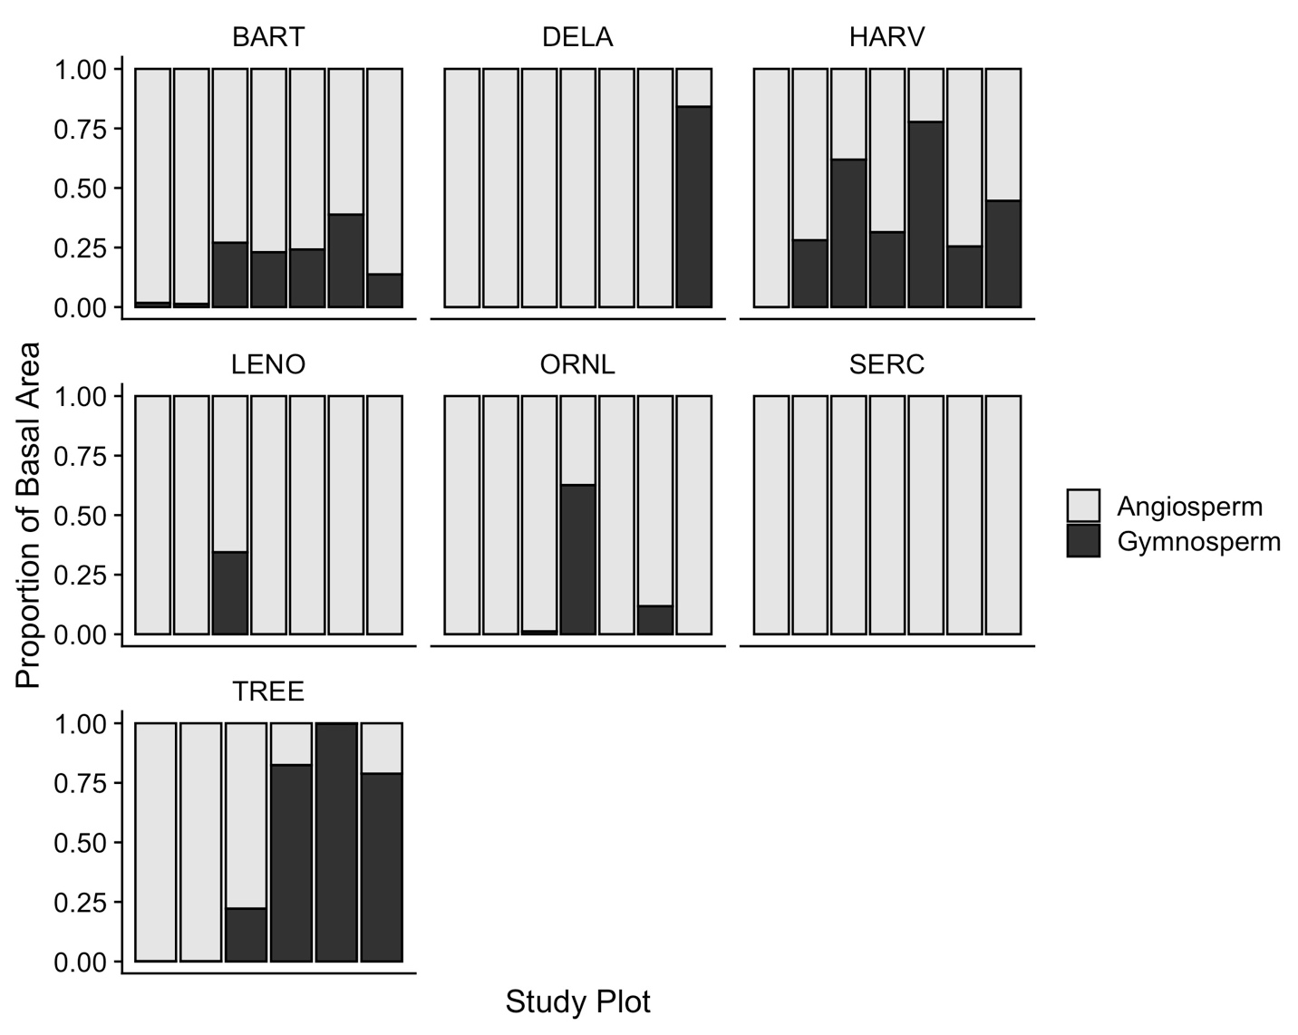

Figure S1. Proportion of tree basal area in each study plot belonging to angiosperms (light gray) and gymnosperms (black). Plots are ordered as in Figure 1, increasing from left to right in the proportion of basal area accounted for by tree species with ectomycorrhizal fungal associations.

Figure S2. Relationships between site-level climate decomposition index (CDI) and a) total tree basal area, and b) soil oxalate-extractable iron content in our study plots. Lines represent linear models using all plots; site means and standard errors represented with horizontal marks and error bars. From left to right, sites are TREE, BART, HARV, SERC, ORNL, DELA, LENO.

Figure S3